**GOVERNMENT POLYTECHNIC, KOLHAPUR**



**MICROPROJECT IN:**

ADVANCE JAVA PROGRAMMING

(ITG405)

**-- DIGITAL UNIT CONVERTOR --**

**SUBMITTED BY:**

OMKAR DATTATRAYA BABAR (226301)

PRASAD SANTOSH PORLEKAR (226306)

**SUBMITTED TO:**

PROF. M. B. PATIL

**2023-24**

**DEPARTMENT OF INFORMATION TECHNOLOGY**

**CERTIFICATE**

Certified that this project report **“ DIGITAL UNIT CONVERTER ”** is the bonafide work of **“ OMKAR DATTATRAYA BABAR , PRASAD SANTOSH PORLEKAR ”** who carried out project work under my supervision.

**PROF. M. B. PATIL**

LECTURER

**PROF. SHOBHA NADGERI PROF. D. M. GARGE**

HEAD OFDEPARTMENTPRINCIPAL

**ACKNOWLEDGMENT**

*I would like to express my special thanks of my project guide* ***PROF. M. B. PATIL*** *as well as our principle* ***PROF. D. M. GARGE*** *who gave me the golden opportunity to do this wonderful project on the topic* ***DIGITAL UNIT CONVERTER*** *which also helped us in doing a lot of research and we came to know about so many new things we are really thankful to them. Secondly we would also like to thank my parents and friends who helped me lot in finalizing this project within the limited time frame.*

*DATE : / / .*

**INTRODUNCTION**

The "Digital Unit Converter in Advanced Java" is a Java-based software application designed to facilitate the conversion of units in various categories, such as speed, temperature, weight, length, data, and currency. This project offers a user-friendly graphical user interface (GUI) that allows users to input values and select units for conversion, providing them with accurate results. This unit converter is a practical tool for individuals, professionals, and students who frequently need to perform unit conversions in their daily tasks

**Key Features:**

1. **User-Friendly Interface:** The application provides a well-structured and intuitive GUI with separate tabs for different unit conversion categories. Users can easily switch between categories to perform the desired conversions.
2. **Multiple Unit Categories:** The unit converter supports a wide range of unit categories, including:
   * Speed: Convert between meters per second (m/s), kilometers per second (km/s), and miles per hour (mile/h).
   * Temperature: Convert between Celsius (°C), Kelvin (K), and Fahrenheit (°F).
   * Weight: Convert between grams (g), kilograms (kg), and tons (ton).
   * Length: Convert between meters (m), centimeters (cm), and kilometers (km).
   * Data: Convert between megabytes (MB), gigabytes (GB), and terabytes (TB).
   * Currency: Convert between Indian Rupees (INR), US Dollars (USD), and Japanese Yen (YEN).
3. **Accurate Conversions:** The application ensures the accuracy of unit conversions by employing well-defined conversion formulas for each category.
4. **Real-Time Feedback:** Users receive real-time feedback on the converted values through labels displayed on the interface. This feedback helps users quickly and easily access the converted results.
5. **Customizable:** The application is designed to be easily extendable. Additional unit categories and units can be added to meet specific requirements or preferences.
6. **Enhanced User Experience:** The project enhances the user experience by providing a custom icon for the application window and incorporating a visually appealing background image within the application.

**Potential Use Cases:**

* Students can use this tool to perform unit conversions for physics, engineering, and mathematics assignments.
* Professionals in various fields, such as engineering, science, and finance, can rely on this tool for quick and accurate unit conversions.
* Travelers can convert currency units to better understand the costs in different countries.
* Programmers and developers can benefit from the data conversion capabilities of this application.

**PROJECT OBJECTIVES**

**User-Friendly Interface:** Develop an intuitive and easy-to-use graphical user interface (GUI) that allows users to quickly understand and operate the unit converter without any technical expertise.

**Multiple Unit Categories:** Implement support for a wide range of unit conversion categories, including speed, temperature, weight, length, data, and currency, to cater to diverse user needs.

**Accurate Conversions**: Ensure the accuracy of unit conversions by utilizing well-defined conversion formulas and following industry standards for each category.

**Real-Time Feedback**: Provide users with real-time feedback on the converted values, allowing them to see the results as they input data and make unit selections.

**Customization and Extensibility:** Design the application to be easily customizable and extendable, enabling future additions of unit categories or units to meet specific requirements or preferences.

**Enhanced User Experience:** Enhance the overall user experience by adding a custom icon for the application window and incorporating a visually appealing background image within the application.

**Testing and Debugging**: Conduct thorough testing and debugging to identify and rectify any issues, errors, or unexpected behavior in the application.

**Performance Optimization**: Optimize the performance of the unit converter to ensure that it operates smoothly and efficiently, even when handling complex calculations.

**User Satisfaction:** Strive to meet user expectations by delivering a reliable and user-friendly unit conversion tool that fulfills their needs and provides a positive user experience

**JAVA PACKAGE USED IN THE CODE**

The provided code uses several Java packages to build the Digital Unit Converter application. Some of the packages used in the project include:

**1. java.awt:** This package provides classes for creating the graphical user interface components, such as frames, buttons, panels, labels, etc.

**2. java.awt.event:** Used for handling events in AWT components, such as ActionEvents for buttons.

**3. javax.swing**: Provides a set of lightweight components that work on the AWT components, offering a more sophisticated and modern set of GUI components, including JTabbedPane, JButton, JLabel, JTextField, etc.

**4. javax.print.attribute:** Used for printing attribute functionality in Java applications.

**5. javax.swing.border:** Offers classes and interfaces for creating and managing borders for various Swing components.

**6. javax.swing.JOptionPane:** Utilized for displaying standard dialog boxes for common user interactions, such as displaying error messages, confirmation messages, etc.

**OUTPUT**

“ **DIGITAL UNIT COVERTER**”

* Enter the amount for conversion.
* Enter the conversion of any unit to another unit.
* Select for first unit for taking input.
* Select another unit for display output

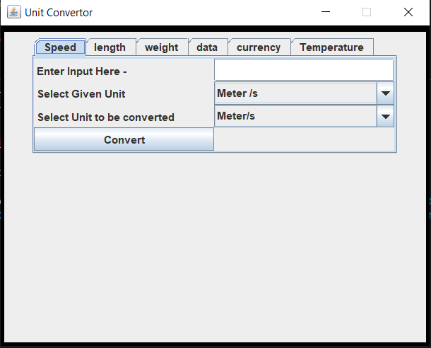

* This is the example to Enter the one unit and display the conversion of another unit.

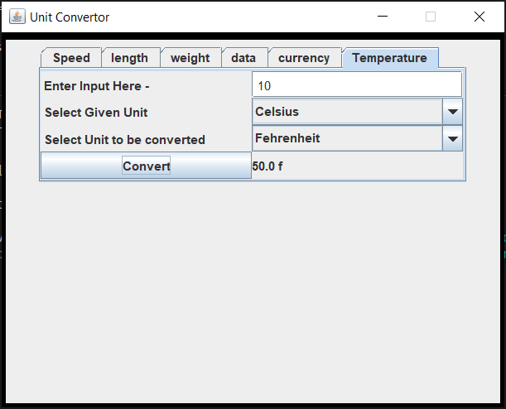

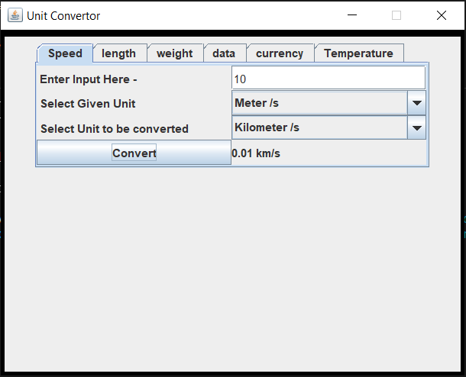

**CONCLUSION:**

The "**Digital Unit Converter in Advanced Java**" project is a comprehensive and user-friendly application that successfully fulfills its objectives of providing a versatile unit conversion tool. The project leverages Java's graphical user interface libraries to create an interactive and visually appealing application.

The **"Digital Unit Converter in Advanced Java"** project successfully addresses the need for a versatile and accurate unit conversion tool. It provides a valuable resource for users who require quick and reliable unit conversions in various domains. With its user-friendly interface, diverse unit categories, and real-time feedback, the project enhances the efficiency of unit conversions and contributes to a positive user experience.

In conclusion, this project demonstrates effective use of Java's GUI libraries and sound software engineering principles to deliver a practical and visually appealing digital unit converter.

|  |  |  |  |
| --- | --- | --- | --- |
| Sr.No. | Assessment parameter | Out of Marks | Obtained Marks |
| 1 | Technical preparedness for pratical | 5 |  |
| 2 | Operating skills/Algorithm/flowchart | 5 |  |
| 3 | Observation /Logic/Program | 5 |  |
| 4 | Results/Output | 5 |  |
| 5 | Safely /Descipline | 5 |  |
| 6 | Total | Out of 25 |  |